Document Based Question
Unit 3 Age of Enlightenment Writing Assignment
Using the primary source documents we have reviewed in class, answer the focus question: “How does the Enlightenment promote citizen involvement in government?”
Your final written response should include several pieces of textual evidence from each of the primary source documents (Locke, Rousseau, and Montesquieu). You should also include the key terms and vocabulary from each of the pieces to help you answer the focus question.
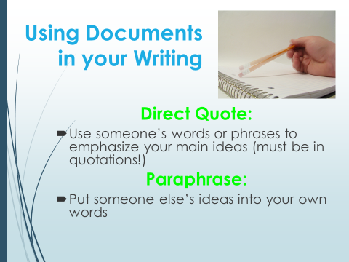
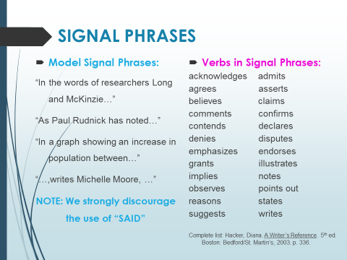
ENLIGHTENMENT DBQ RUBRIC | Basically did you… | Scale:  1-10
Thesis Statement: Thoroughly addresses the direct focus question by accurately analyzing and interpreting the documents with a thesis statement. | - Have a clear opening thesis statement  - Maintain directness to the prompt throughout the essay
Documents: Uses descriptive and analytical information directly from the documents within the response | - Use each of the documents within response  - Do a good job connecting the documents to the topic sentence by explaining, giving details and examples
Development: Writes a well-developed response using multiple paragraphs; consistently demonstrating a logical and organized thought process | - Write in complete sentences  - Have a clear introduction and conclusion  - Self-edit for structural and grammatical errors

Total: / 30

