New Nations Emerge Vocabulary
Word Bank: African National Congress, Afrikaners, apartheid, British Raj, bureaucracy, civil disobedience, decolonization, exploitation, Indian National Congress, monarch, partition, Salt March, segregation, Social Darwinism

Definition | Term | Illustration
(1) the action or state of dividing or being divided into parts | Decolonization
(2) the refusal to comply with certain laws or follow government orders as a peaceful form of political protest to bring attention to a perceived injustice and force change
(3) a system of government in which most of the important decisions are made by state officials rather than by elected representatives
(4) | Salt March | 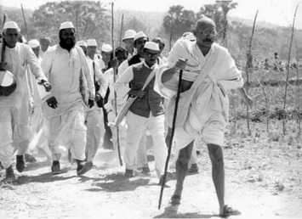
(5) people who are descendants from the first Dutch colonists in South Africa
(6) an organization founded in 1885 to improve the rights and status of Indians in British colonial India and a major political party in India since its independence in 1947 |  | 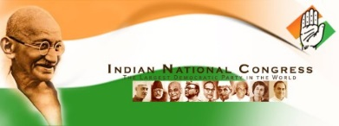
(7) | Segregation
(8) | Apartheid
(9) the 90-year period of British colonial rule in India that took place between 1858 and 1947 |  | 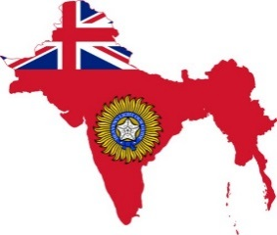
(10) the group formed in 1912 who used marches, strikes, and other protests to promote black rights throughout South Africa
(11) | Exploitation
(12) the theory that individuals, groups, and peoples are subject to the same Darwinian laws of natural selection as plants and animals; used to justify imperialism and racism in the late 19th century | Social Darwinism
(13) | Decolonization
(14) | Monarch

Gandhi: Man of Peace Comprehension Questions

Directions: After reading the Junior Scholastic “Gandhi: Man of Peace” article, answer the following questions.

- After what experience in South Africa did Gandhi decide that he would campaign for human rights?

- What was satyagrapha?

- After the British passed the Rowlatt Acts, what did Gandhi encourage Indians to do?

- What difficult decision did Britain face as a result of the Homespun Campaign?

- What did Gandhi accomplish on his Salt March?

- When was India’s independence achieved?

- How was India divided by the British?

- How did Gandhi feel about the division of India and Pakistan?

