POLITICAL CARTOON ANALYSIS ASSIGNMENT!
MINOR GRADE
CARTOONS ARE DUE ON MONDAY, MARCH 14TH
- Find a political cartoon that represents two of the major economic systems during the Cold War
- For each cartoon include the following:
  - What people or countries are represented in the cartoon?
  - Is it showing the government in a positive or negative light? How do you know?
  - What is the message of the cartoon?
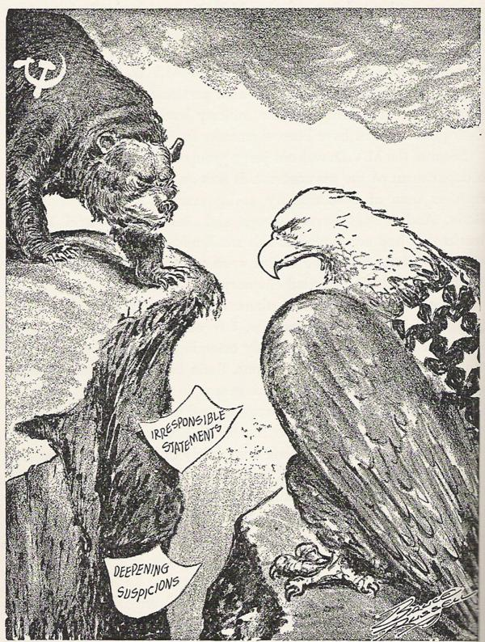
  - Choice: Create your own political cartoon with a clear message about one of the major economies during the Cold War. (This can only be used as one of the two examples)

